Lincoln EEA Chapter 1541
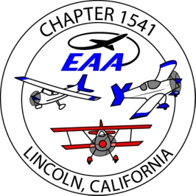
Member Meeting , at Hangar S-12, 6pm
July 20, 2016
- Voted on amending the Chapter Bylaws ; approved , 42 for, 1 against
The secretary will publish the new bylaws to the membership by email
- Treasurers report; account balance $22,312.88, hangar funds $12,988, general funds $9,324
We have 92 paid members ; added Fred Mann and Jack Allison , 24 gold members; added Marty Maisel, Clark Osterhout and Betty Kisbey. These dues ad donations will be added to the August report.
- Our Christmas Party is Dec. 14 . A planning committee is being organized with Bill Wootton
- The newsletter needs articles, contact Scott Thompson.
The newsletter name was changed by the members voting to; ‘Runway 15’
- Bruce Estes mentioned a flying scavenger hunt as a possible chapter event. It will be discussed further.
- The presentation was on powered parachutes by Kevin Finney.
- Sold 9 t-shirts and dinner ; $200
So, we have $ 840 to deposit .
- We took up a collect for donations for Sarah Ogilvie and Grace Simons for transportation to/from the Oskosh Young Eagles camp .
- The treasurer/secretary will email the updated Chapter Roster to the Board of Directors.

Submitted; Jim Hughes, treasurer/ secretary

