Lincoln EEA Chapter 1541
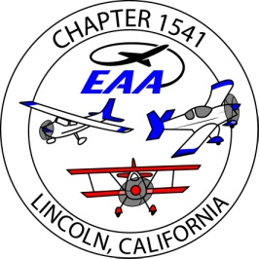
Board Meeting, at Pizza Roundup
Oct., 05, 2016 , 6pm
Present; Ron W., Tony K., Jim H., Bill W, Bob M, Tom L, Bruce E, John P., Dug Smith, Bruce Robinson,
Absent; Bill Wootton
guests; none
- The Fly Baby kit… is it useful for the STEM program; does it fit ? We’re not sure.
possibly sell it to a member, and allow use of the hangar.
We need to establish a relationship with a local HS first, to see if there is any interest.
- Tony all set of the Golden west fly-in
- Help needed at the AUN air Fest, 10-08
- This month’s speaker is Marty Maisel, ‘Hollywood and Aviation’.
- Newsletter; Scott published 2 issues, and still needs more articles.
- Bruce E., continuing working to sell the donated instruments.
- STEM, Bruce R., Granit Bay HS has and aviation club with 4-6 members, with 5 more interested.
ron to vist one of their meetings to give them info on what we can offer.
- Hangar; the city airport committee continues meeting. The Oct 19 meeting may review standards for ground rents ? Bruce and Jim will attend and report.
- We need input on organizing the Christmas Party….tickets , Danny Hull music ?
- Treasuer’s report - $22,269 in the Umpqua account, $ 13,098 are hangar funds, $ 9,171 are general funds.
- The roster is prepared for 2017 dues
membership is 102, 25 gold.
- Renewed the ‘EAA1541.org’ website.

Submitted,
Jim Hughes
treasurer/ secretary EAA1541

