Lincoln EEA Chapter 1541
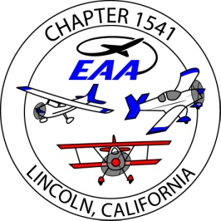
Board Meeting, at Pizza Roundup
Nov., 02, 2016 , 6pm
Present; Ron W, Jim H., Bill W, Bob M, Tom L, Bruce E, John P., Dug Smith, Bruce Robinson,
Absent; Tony K.
guests; Patty M, Jody W.
- The Fly Baby kit… decided to not want the kit.
- Golden west fly-in – canceled due to weather
- This month’s speaker may be Chris Brooks, from the office of airports, aeronautics Div of Caltrans.
If he is not available, JimH. will do one of the FAASety Team, ‘Topic of the Month’.
- Newsletter; Scott published 2 issues, and still needs more articles.
- Bruce E., sold 2 of the donated instruments for $750.
- STEM, Bruce R.,plans to contact Granit Bay HS has and aviation club with 4-6 members, with 5 more interested.
Ron to visit one of their meetings to give them info on what we can offer.
- Hangar; the city airport committee continues meeting. The Oct 19 meeting reviewed more info on master leases, esp. Nunno. Presented 3 options fro master leases..

- Bill Wootton is organizing the Christmas Party….have proof tickets ,need to contact Danny Hull on music ?
Need raffle items for the ‘silent auction’
Tickets need to go on-sale in Nov. , include in the newsletter who to see for tickets.
Voted Jody Wootton a complimentary membership with her helping with the Christmas Party plans.

- Airfest 2017 will be 2 days, the 2nd day a STOL competition, and an opportunity to increase revenue from this.

- Jim H. reviewed a proposed budget for 2017. We will refine this and present it to the membership in Dec.
review food costs, look into sponsorships and ads in the newsletter.
- Treasurer’s report - $21,643 in the Umpqua account, $ 12,598 are hangar funds, $ 9,045 are general funds.
- The roster is prepared for 2017 dues
membership is 104, 25 gold.
Submitted,
Jim Hughes
treasurer/ secretary EAA1541

