Lincoln EEA Chapter 1541
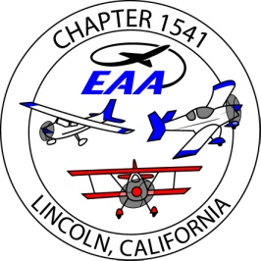
Board of directors Meeting , at Pizza round up
December 07, 2016 , 6pm
Present; Ron W., Jim H., Bill W, Bob M, Bruce E, John P., Dug S.
absent; Tony K., Tom L.
guest; Scott T., Patti M.
Filled in the info for our EAA chapter renewal. JimH. to file
Christmas party; sold 60 tickets, Aun 526 will join us, with 15-25. The silent auction has 15 items. The 50/50 raffle will be $5 . Danny Hull and 2 members set for music, cost $250.
Treasurers report ; Umpqua acct. $21,392, hangar funds $13,108, general funds $8,284. Total donations for 2016 are $8,860.
A 5th wheel trailer was donated this week; 1989 Komfort, 24 ft. needs some repair. Estimated value of $1,000 to $1,500. Send email to membership once the board agrees on a value. Also add to newsletter in Jan.2017
Our Calstar/Reach renewal is coming up. Ron to advise on renewal cost.
Question; if we are supporting the Tri-motor at MYV and SAC..? tbd.
Youth Aviation;
Bruce R. is the leader on this project.
cooperate with Rancho Muretta, Kim Smith on drone projects, FAA 107 pilots and tbd.
use ‘meetup’ to reach out; filter YE. Increase parent exposure to general aviation, and Eagle flights.
possibly use a public outdoor venue like Raleys patio.
List meetings/ activities as an FAA safety seminar.
continue to evaluate possible STEM activities.
possible offer ‘park flyer’ , 2 channel electric model aircraft training flights.
A reminder that our Jan. and Feb 2017 member meetings are at Cattlemens, with the cold, dark weather.

Submitted,
Jim Hughes
treasurer/ secretary EAA1541

