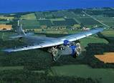 FORD TRI-MOTOR
COMES TO LINCOLN

We need ideas! …and we need volunteers to make it work.

Here is a start:

- Ground crew each day

- Collections

- Public safety

- Ford sponsorship

- Parking

- Photography

- Local advertising

- Shirt sales

- Refreshments/Food

- Tri-Motor crew entertainment

