Lincoln EEA Chapter 1541
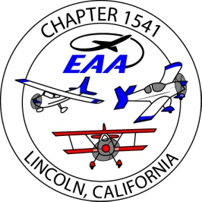
Meeting of the Board of Directors
June 01, 2016
The meeting convened at 6:30 pm at Pizza Round Up.
Present – Ron Wright, Tony Kasabascih, Richard, Pearl, Jim Hughes, Bruce Estes, Dug Smith, Tom Lieb.
Ron appointed Tony K. as Vice President, replacing Ken Schwartz, who has resigned.
Discussed the duties to be assigned to the officers.
Vise President is to organize the member meeting dinner and set up crew.
Treasurer is to maintain the P O Box, the bank account, member roster and the email account
Secretary is to take the BOD meeting minutes and email them to the membership, publish the newsletter.
JimH. reviewed the hacked chapter email account. It is now recovered and accessible.
Agreed to sell the soda machine. We have more need for another refrigerator.
Talked about the hangar land lease and the city not deciding their policy on renewal.
Talked about Dick Rupe, as hangar boss, needs to develop a list of work to be done;
seal leaks in the roof, perimeter, wall insulation.
Set responsibilities for the ‘Open Hangar Day’, Sat 6/04; breakfast and a movie.
Discussed final preps for the Airfest – the breakfast crew and raffle.
Richard P. did a brief review of the Airfest preps – a professional ‘Tug’ group will move the war-bird, ‘big iron’, Lincoln PD will provide security.
Discussed names for a new board member to replace Tony K.

Adjourned at 7:30 pm
Submitted; Jim Hughes, treasurer
[ from my brief notes ]

