Lincoln EEA Chapter 1541
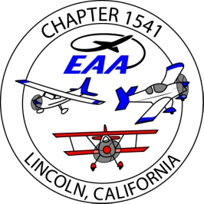
Board Meeting, at Pizza Roundup
Sept., 07, 2016 , 6pm
Present; Ron W., Tony K., Jim H., Bill W, Bob M, Tom L, Bruce E, John P., Dug Smith,
Absent; Richard Ryan
guest; Bruce Robinson, Paul Darbo., Nick Suciu, Jack White
- Our Sept 21 guest speaker will be Kimberly S.- Smith, the EAA 1476, at Rancho Murieta, doing a presentation on their ‘Youth Aviation’ program. It is 2 parts, youth aviation camp and now Drone pilot program.
- Ron appointed Bruce Robinson as a board member, to replace Rich Ryan.
- Bruce E. still has the instruments for sale. Scott To put a ‘for sale’ ad in the newsletter
- Bill W. – setting up Cattlemens for our Christmas Party – 125 folks max., 5 entrees , cash bar[ tbd], need to print tickets, any raffles ?
- Need to renew the CA raffle permit. Ron.
- Tony will be gone for the 9-21 member meeting – Jack W will organize dinner.
- EAA Hangar, plan to replace the roof panels on Sat, 9-10 [ done]
A discussion on the ground lease uncertainties , from the 9-07 Airport Committee meeting… JimH. will attend the next meeting..
- Golden West Fly-in and EAA chapter competition – voted to assign Tony K. to organize this. Jim h. will forward the info from Jim Booth, EAA GV, who is organizing the event.
- Jim H. to send the BOD the link to the airport committee meeting minutes and agendas.
- Ken needs to know who will be at his home on Fri- Sun..

Submitted,
Jim Hughes
treasurer/ secretary EAA1541

